**EAV TEST**

**Create an avatar attribute for a customer**

* Create a custom attribute for Customer named “avatar”
* Create a upload field in customer edit (at backend) to upload the avatar (see example)

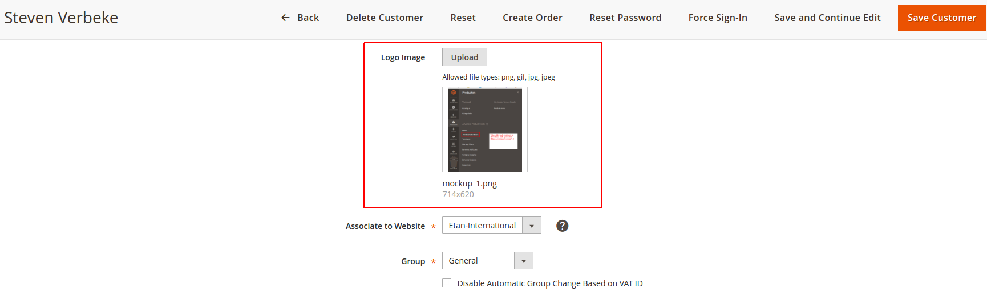

* After upload, the image can be previewed (Magento already supports this with uploading component)
* When the customer is saved, the avatar attribute is saved as text and its value is the relative path to the file in the server (E.g: pub/media/customer/test.jpg, pub is a folder in Magento)
* Show the Customer Avatar along with some info at frontend (in customer dashboard face)

